# Lab #4: Dancing lights

In this lab you are required to handle the seven segment displays on the FPGA boards using sequence of operations. The following image is used as a reference in this lab.

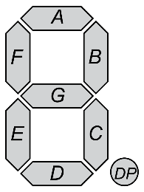 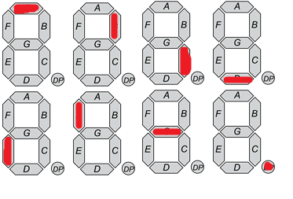

The first image shows the naming of the segments while the second figure shows the intended display with the eight time snapshots each about 1ms apart.

The assignment entails a sequence of operations wherein first the segment A is lighted. Then it is switched off and segment B is lighted. Then segment B is switched off and segment C is lighted. This process continues till segment G is lighted. After this segment G is switched off and segment DP is lighted.

The same process is then repeated for each of the 7-segment displays by controlling EN0, EN1, EN2 and EN3.

Each step is carried out in about 1ms interval. Thus in a total of ~30 ms, entire operation is done on all four displays and the entire process is carried out repeatedly till the board is switched off.

## Procedure.

1. Use the 25MHz clock on the FPGA board to generate about 1KHz clock by using a circuit that divide by about 16384 (214). Use a 13-bit counter for this that is incremented at 25MHz clock. If keep counting up to 8191 and then wraps around to 0 (since the counter is 13 bit, it would happen automatically). Generate an output called working_clk that is toggled whenever the 13-bit counter reaches zero. Develop this module as a separate module.
2. Use the working_clk to develop the dancing lights creating an 8-bit value representing {DP, G, F, E, D, C, B, A}. It is set to 8’b11111110 to light up A. At each positive edge of the working_clk shift left this 8-bit value (actually rotate left. Figure out how to do this).
3. Maintain a four bit EN carrying {EN3, EN2, EN1, EN0} and initialize it to 4’b1110. When DP is shifted from 0 to 1 (i.e. posedge of DP), rotate EN let by one bit.
4. Define the UCF file for the input output as described above. Synthesize your code for the FPGA and download the bit file on the FPGA. You shoul be able to see the dancing lights as soon as you power on the circuit.